FACE- RECOGNITION ATTENDANCE SYSTEM

BY- SREYA SHYJASH

BTECH CSE CYBER SECURITY

3RD YEAR

INDEX

|  |  |  |
| --- | --- | --- |
| SI.NO | CONTENT | PAGE NO. |
| 1. | AIM |  |
| 2. | INTRODUCTION |  |
| 3. | METHODOLOGY |  |
| 4. | CODE |  |
| 5. | **Results and Testing**: |  |
| 6. | **Conclusion** |  |

AIM

To develop a **web-based attendance system** that uses **real-time face recognition** to automate student attendance, improve efficiency, ensure accuracy, and minimize the chances of proxy attendance in educational institutions.

INTRODUCTION

Traditional attendance systems are often time-consuming, error-prone, and susceptible to proxy attendance. The Face Recognition Attendance System addresses these issues by leveraging real-time facial recognition technology through a webcam.

This system is built using **HTML, CSS, JavaScript (Face-API.js)** on the frontend and **PHP with MySQL** on the backend. It supports role-based access for **Admins** and **Lecturers**, allowing seamless student registration, course management, and attendance marking. The system is deployed locally using **XAMPP** for easy testing and development.

METHOLODOGY

The project was developed using the following methodology:

1. Requirement Analysis:
   * Identified the need for an automated, reliable attendance system.
   * Decided on role-based access control: Admin vs Lecturer.
2. Technology Stack:
   * Frontend: HTML, CSS, JavaScript
   * Facial Recognition: Face-API.js (runs in-browser)
   * Backend: PHP
   * Database: MySQL (via phpMyAdmin)
   * Server: XAMPP (Apache server + MySQL)
3. Modules Implemented:
   * Login System: Role-based login for Admin and Lecturer.
   * Admin Dashboard:
     + Add new students with image capture for recognition.
     + Manage courses, venues, and lectures.
     + Export attendance as Excel files.
   * Lecturer Panel:
     + Open camera and mark attendance based on face detection.
   * Face Recognition:
     + Face-API.js loads trained face descriptors.
     + Matches live webcam input with registered faces.
4. Testing & Deployment:
   * Hosted and tested on XAMPP.
   * Verified live camera access and successful recognition.
   * Ensured Excel exports and database logging work correctly.

CODE

These are the files required. The codes are provided in the GitHub.

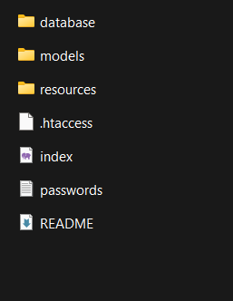

RESULT AND TESTING

The system functions successfully, with the following outcomes:

* Real-time facial recognition is accurate and fast under normal lighting conditions.
* Attendance is logged automatically when a student’s face is detected.
* Admins can easily manage students, courses, and lectures.
* Lecturers can mark attendance without needing access to other system features.
* Attendance data can be exported to Excel, facilitating report generation.

Screenshots verify the system’s successful implementation, including login, registration, and real-time webcam-based recognition.

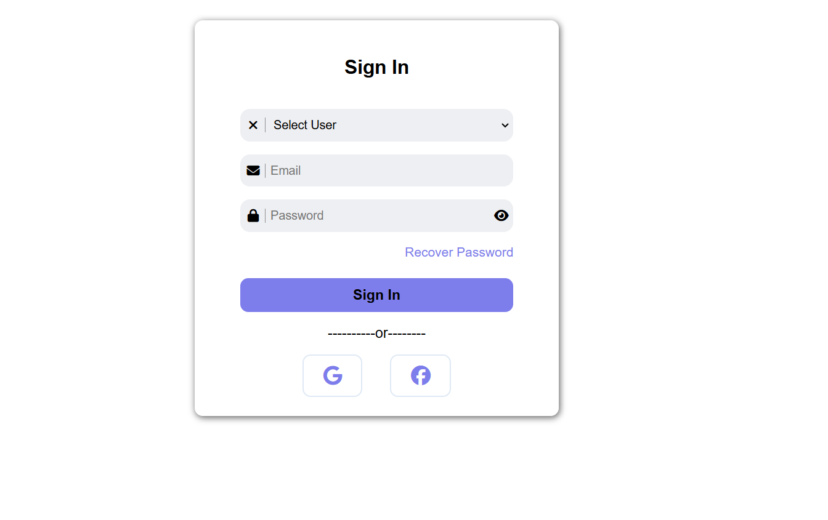

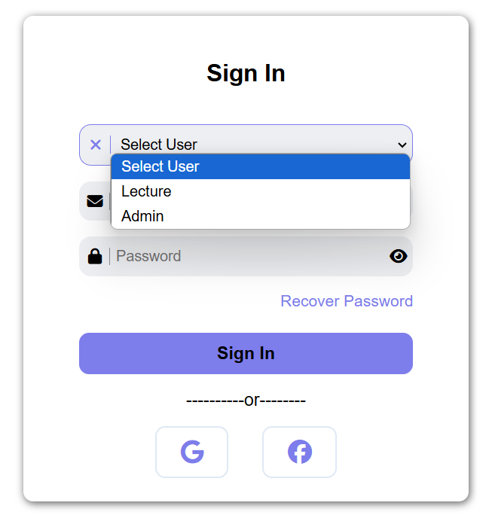

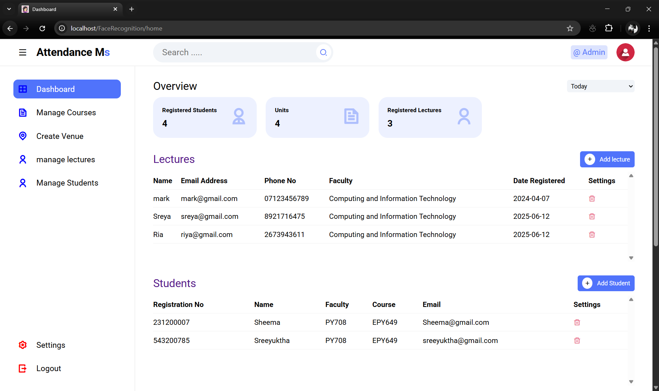

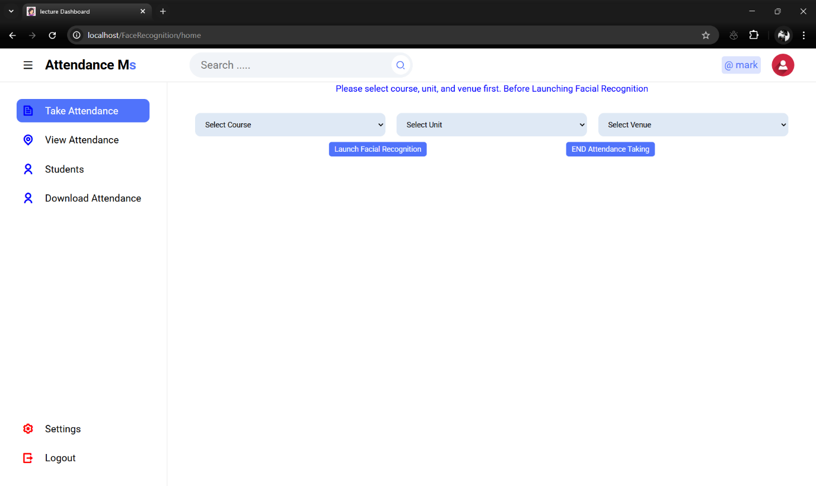

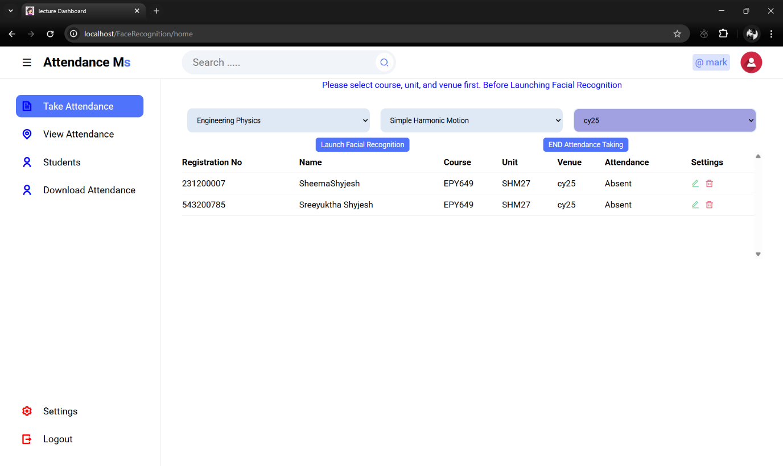

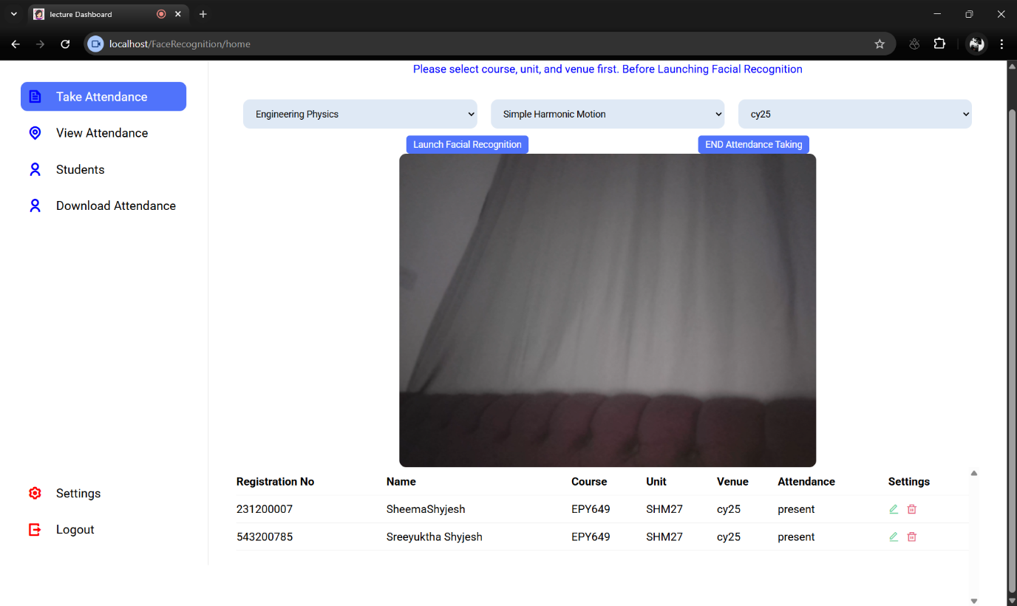

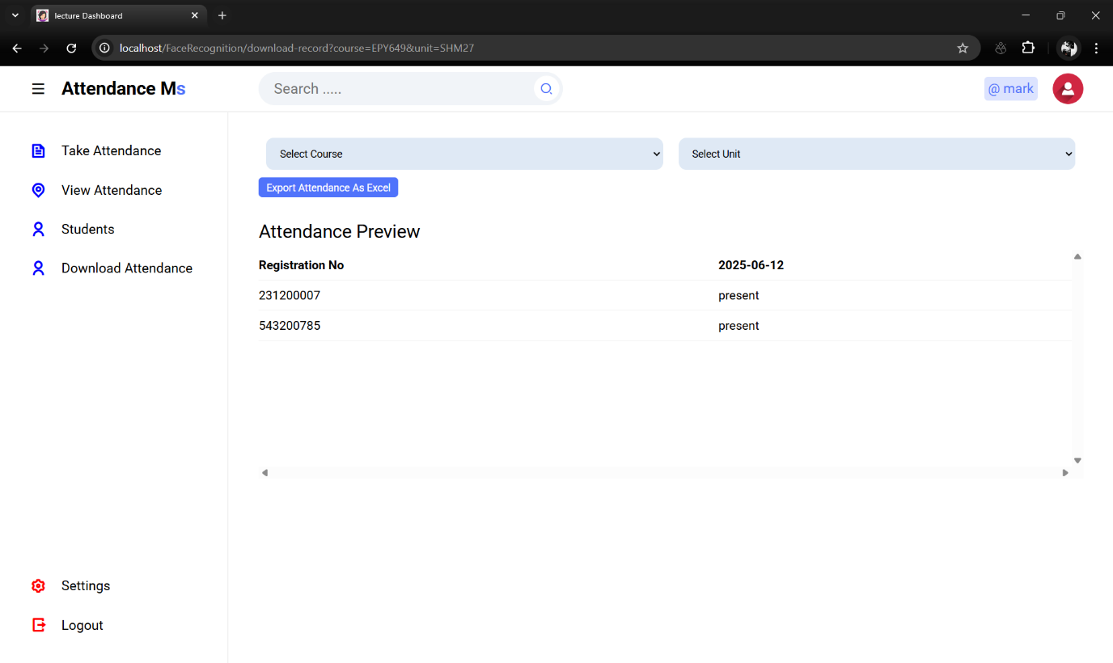

DOWNLOADED EXCEL SHEET WITH ATTENDANCE MARKED.

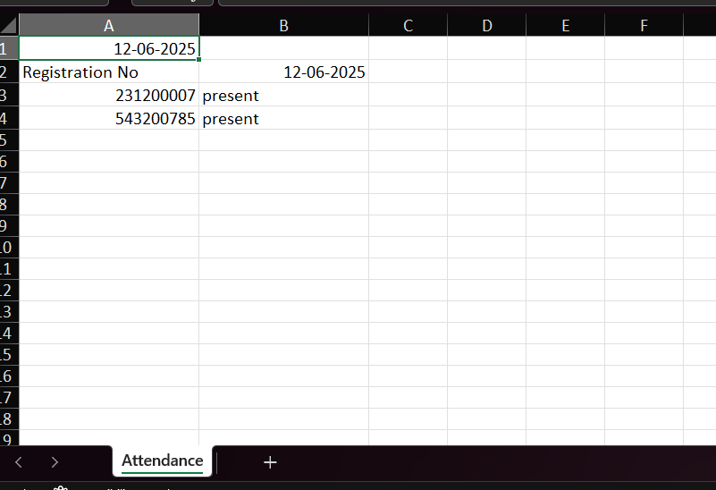

CONCLUSION

The Face Recognition Attendance System offers a modern and secure alternative to manual attendance methods. By utilizing web technologies and real-time face detection, the system ensures accurate attendance recording while saving time and reducing administrative overhead.

Its modular design and use of open-source tools make it a scalable solution for educational institutions looking to modernize their attendance process.